HHH: An Online Medical Chatbot System based on Knowledge
Graph and Hierarchical Bi-Directional Attention

What is the paper about?
This Paper produces an efficient chatbot framework for building Q&A(Qusetion and Answer)system to evaluate intricate medical questions.This initatve was undertaken by the government and the healthcare providers in order to reduce time in making appointments , waiting in long queue , access to small medical sercvices and make use of digital medical data along with information technology to deliver services to people in need.To develop this use case and further to implement this chatbot framework ,with various advancement of information technology they have adotpted artifical intelligence techniques to develop this chatbot framework . Also since many assistance software in medical industries are primilarly build on AI ,drastically have proven to imporve healthcare needs. Recently huge number of chatbot systems has been proposed for the medical industry to help with , customer care , identify medidal symtoms , assist doctors , etc.Ideally their works has
3 main objectives. First objective is minimize waste on resources and to create a human like interface so that users can have easy access to the chatbot software
The Second Objective mainly focus on the system understanding natural language and deliver high responive quality feedback which includes roling out
accurate answers to users with vague idea of medical domain and medical expertise.Third Objective is to make the system sophisticated to manage to provide better and increasing features to the chatbot framework and datatbases.
Here, the intially the framework was desgined and this chatbot framework has
two main modules.The first modules consists of front end system which contains a GUI and back end system to hold databases. The Second module comprises of servers to answer to users quereis and to propogate data back and forth.The second model has built in hybrid model such as Knowledege Graph
and hierarchical BiLSTM attention model (HBAM) along with these model siamese framework also has been introduced in learning tasks , to address sentence simlarity mannhattan distance is widely used such as cosine simliarity.
So the rest of the paper is differntiated along other findings such as
1)problem fromulation and related work
2)System Architechture
3)Knowledge based graph Architecture
4)HBAM(Hierarchical BiLSTM attention model)
4)Result Analysis
5)Conclusion and Future Work.

What are the authors doing that is new ?

Here the authors are identifying two main main problems that are preesent at the heart of the chatbot framework , First problem is based on whether the chatbot can identify the ability of natural language and to develop
certain NLU and NLP techniques to to process users questions.
The second problem deals with extraction of data from Internet or a database so that the users queries are produced with a feedback.
Also the authors have considered many proposed work in order to develop this chatbot , such as Knowledge Base Storage and Retrieval.with help of RNN and CNN and other work considered in by knowledge graph to implement , store and retrive users data from the internet .The other work that has been considered is Siamese based Semantic sentence similarity.here a Siamese Long Short-Term Memory (LSTM) net-work to compute the semantic similarity between two variable- length sentence. Authors here also implemented System architecture know as the – HHH System Architecture holds wo chatbot clients (website and GUI) connect with a chatbotone manager client communicates with a manager server.a hybrid QA model aims to respond to the messages from
the chatbot server with two datasets (a knowledge graph,
and a medical QA pair dataset) that are managed through
the manager server A question-and-answer framework that combines knowledge graph and HBAM.
Implementation of two models for our medical chatbot system
1) Knowledge Graph model -
Consisting of 3 entities (department, disease, and symptom), 6 properties (name, description, cause, prevent, accompany,
cure_way), and 5 relationships (have_symptom, accompany_with, disease_prevent,disease_cause, disease_cureway).Answer feedback from the knowledge graph here its performed by using Aho-Corasick algorithm.
2)HIERARCHICAL BILSTM ATTENTION MODEL -
Dervied from the QA datset works by the action of LSTM-based sequence encoder ,Entity detection and Intention recognition and a simlarity funtion.

Did it Work ? Why or why not?
The experiment yielded a great amount of results but there are still works needs be done regarding these
methods
Two Experiments were conducted here
Experimnet 1 : Training and Testing Dataset : Since it is trained and tested on medical dataset available from quora the model filters out medical subsets which means things related to medical field here a medical dictionary has been created the dictionary contains many medical terminologies.
To evaluate the dataset here it has been compared with top line pre – existing models such as BERT and MALSTM , BERT was proposed by google in 2018 by google , MALSTM was proposed by MIT in 2016
Below is the comparsion data

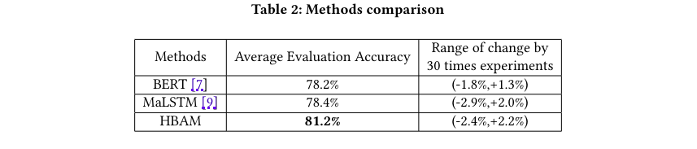
Experminet 2 : Approxiamatley around 50000 medical data sentences has been user here the follwing experment took 10 across the combination of 2 datasets
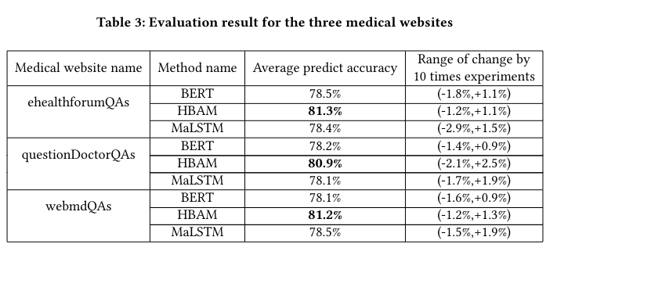
4)Why is this Good or BAD ?

The Scalability of research paper always has its upside and downsides but ideally this research paper has good metrics of providing more complex and positive results and in the future it may produce great patents regarding the use of chatbot in the medical fields. Since also techically been proven that HBAM is compartively perfoms better to BERT and MALSTM.

5)Technical Specification of the Paper

Have experimented the deep learning mod-
els on Google Colab13 (Tesla K80 GPU, 12 GB RAM) to validate
the semantic similarity between two sentences. The hyperparame-
ters of HBAM includes the batch_size is 1024, the n_epoch is 9, the
n_hidden is 100, the embedding_dim is 300 and the max_seq_length
is 10, GoogleNews-vectors-negative300.bin.gz from Word2Vec14,
the activation function is tanh

6) Conclusion

The chatbot framework is proposed ideally to enhance the use of existing technology and also use machine learning algorithm ssuch deep learning and sentiment analysis to orchistrte the chatbot framework and propose a new algorithm called HBAM with other existing state of the art algoritm such as
BERT and MALSTM.
Many things are yet to discovered their future work includes not only to apply chatbot framework to medical industries but every specific domain.

